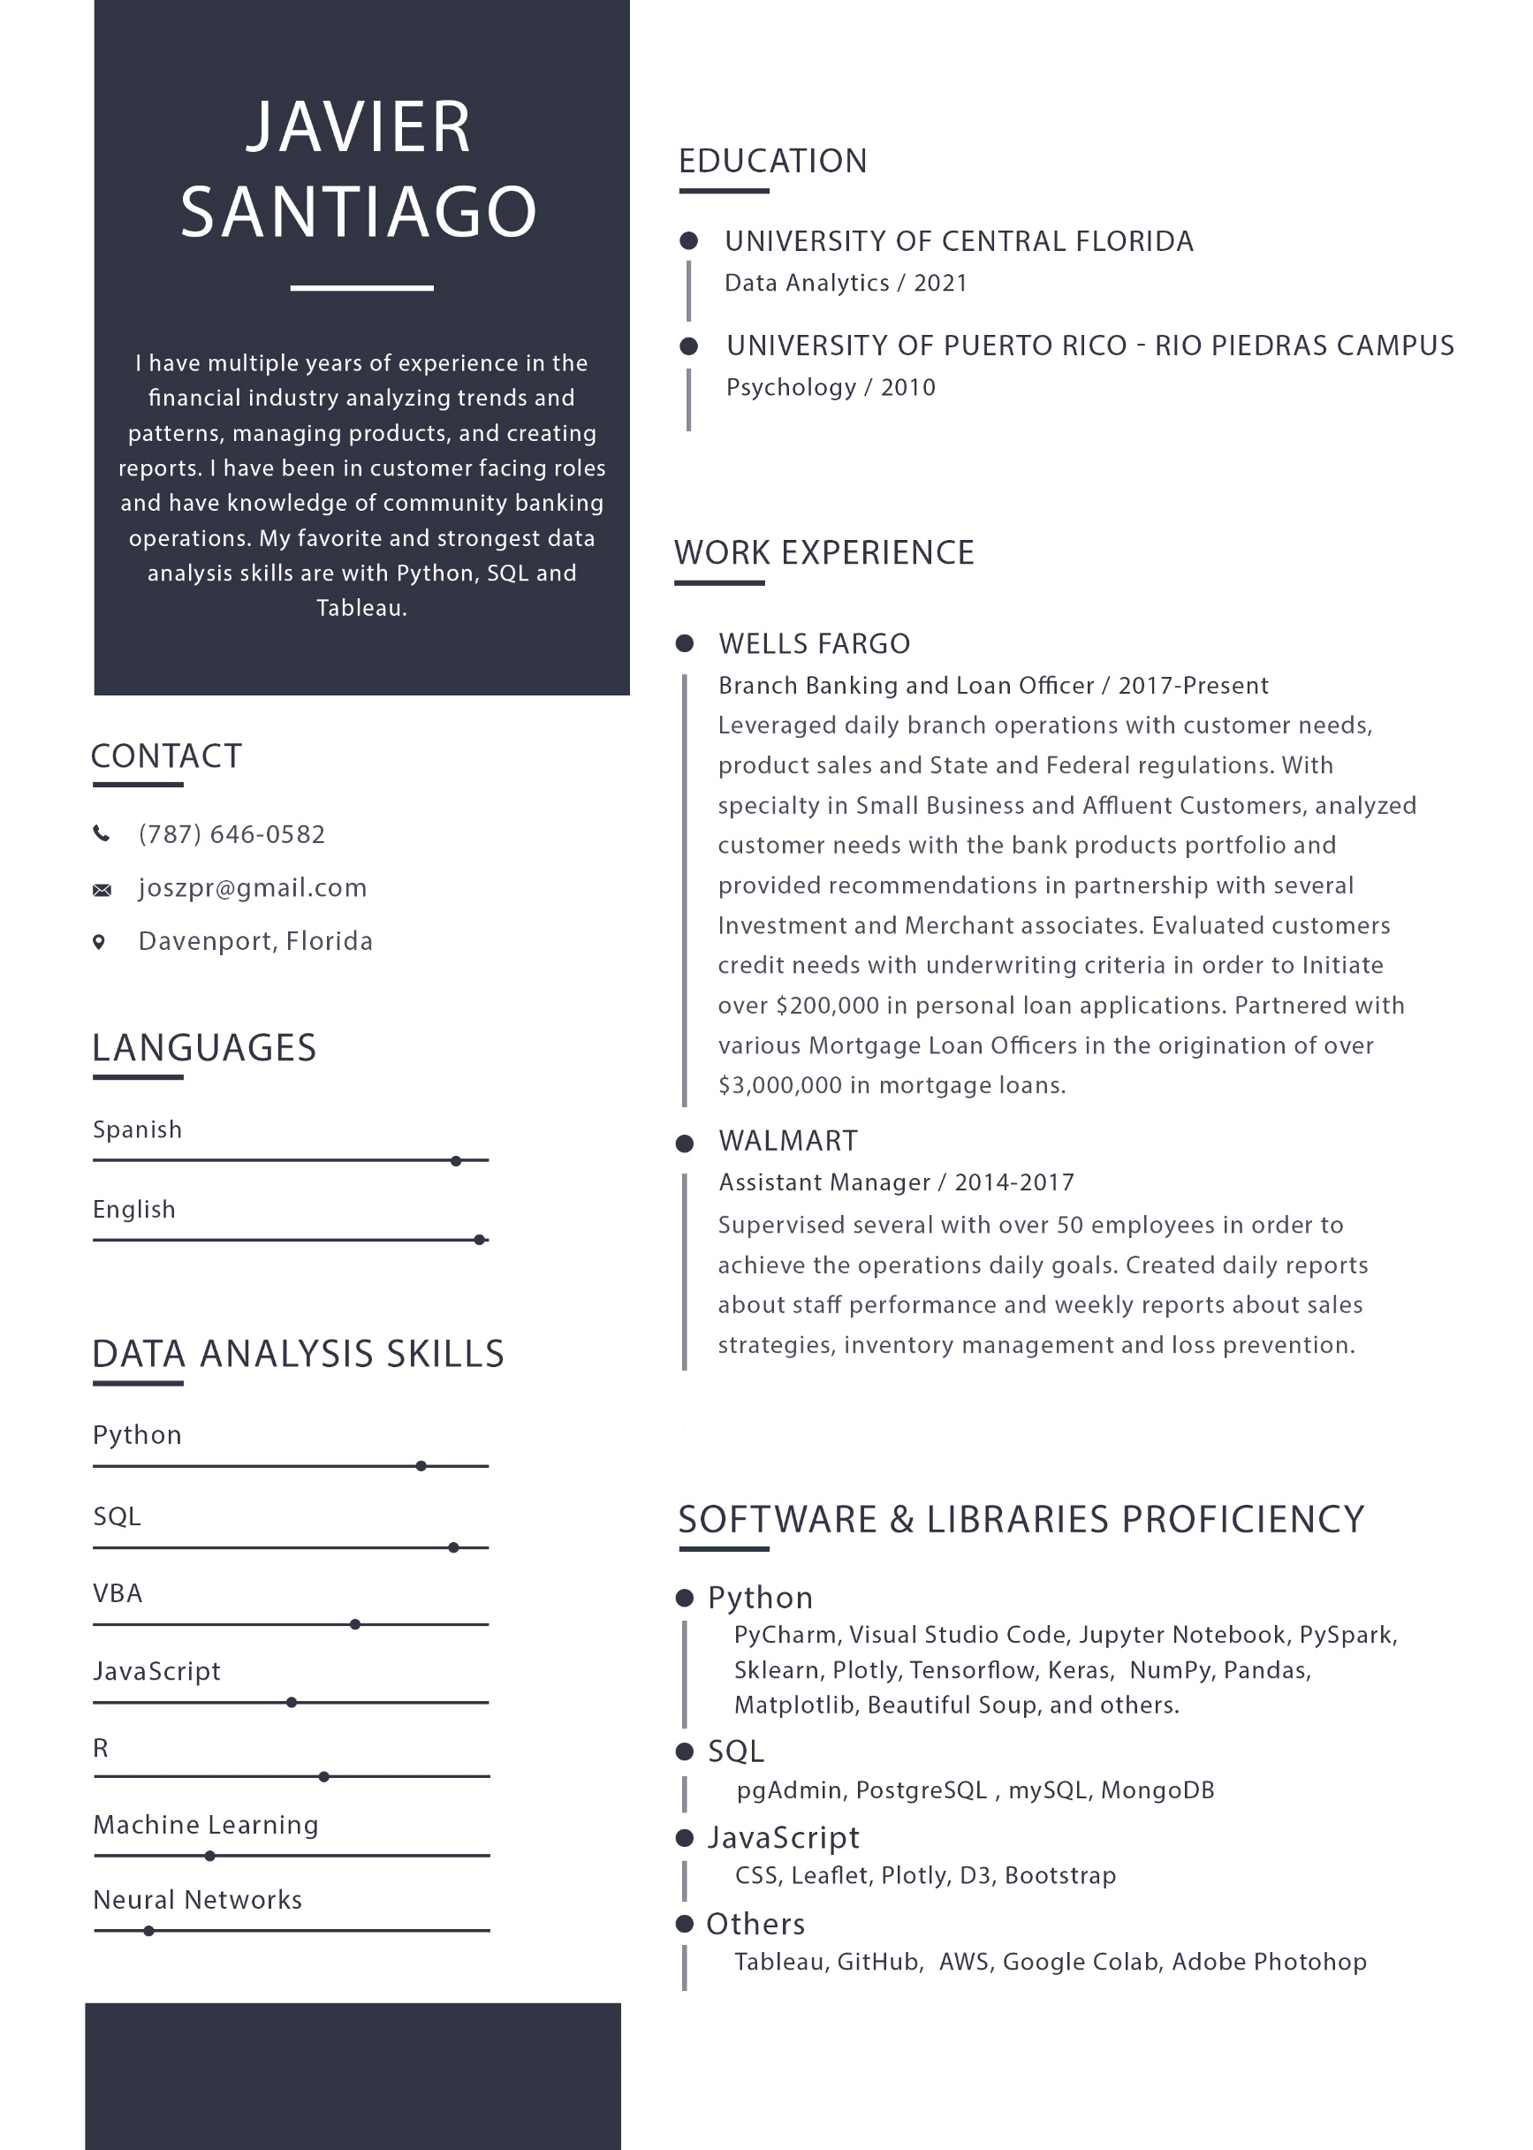

Name: Javier Santiago

Phone: 787-646-0582

Email: [joszpr@gmail.com](mailto:joszpr@gmail.com)

Location: Davenport, Florida 33837

Languages: English and Spanish.

Position: Data Analytics

Education:

Data Analytics Degree from the University of Central Florida

Summary: I have multiple years of experience in the financial industry analyzing trends and patterns, managing products, and creating reports. I have been in customer facing roles and have knowledge of community banking operations. My favorite and strongest data analysis skills are with Python, SQL and Tableau.

Skills

Data Analysis Skills: Python, SQL, VBA, JavaScript, R, Machine Learning, Neural Networks, Tableau Software, PyCharm, Visual Studio Code, Jupyter Notebook, PySpark, Sklearn, Plotly, Tensorflow, Keras, Numpy, Pandas, Matplotlib, Beautiful Soup, pgAdmin, PostgresSQL, MySQL,MongoDB, CSS, Leaflet, Plotly, D3, Bootstrap, GitHub, AWS, Google Colab, Adobe Photoshop.

Work Experience

Branch Banking and Loan Officer Experience with Wells Fargo 2017 – Present

Leveraged daily branch operations with customer needs, product sales and State and Federal regulations. With specialty in Small Business and Affluent Customers, analyzed customer needs with the bank products portfolio and provided recommendations in partnership with several Investment and Merchant associates. Evaluated customers credit needs with underwriting criteria in order to Initiate over $200,000 in personal loan applications. Partnered with various Mortgage Loan Officers in the origination of over $3,000,000 in mortgage loans.

Assistant Manager with Walmart 2014-2017

Supervised several with over 50 employees in order to achieve the operations daily goals. Created daily reports about staff performance and weekly reports about sales strategies, inventory management and loss prevention.